Collaborative OER adoption by a Professional Learning Community, a model of Teacher Professional Development
Theme 4 – ICT in Teacher Professional Development (TPD)
Authors → Sri. Gurumurthy Kasinathan, Director IT for Change and Ms. Sriranjani Ranganathan, Deputy Director IT for Change
First Author → Cell: 98454 37730 Mail: Guru@itforchange.net
Table of Contents
Background 1
Context of Indian education 2
Availability of educational resources 2
Experimenting with digital resources 3
Quality of teacher development 3
The Subject Teacher Forum and Karnataka Open Educational Resources 4
Objective of this study 6
Methodology 6
Email analysis 6
Focused Group Discussions 7
Findings 7
Digital resource creation process 7
Analysis of emails shared in the PLC 9
Responding to mails 9
Kinds of mails 9
Format of resources shared 11
An understanding of the nature of OER 11
Big data analyses of the PLC mails using Watson 13
Dialectic between the OER core group and the PLC 14
Membership of the core group 14
PLC both a source and context for OER creation 17
Influence of PLC interactions on OER design and creation 17
PLC as a forum for disseminating OER 18
Challenges 19
Conclusion 20

Background
The authors, as members of IT for Change, an NGO working in the area of digital technologies and social change, participated in the ‘Subject Teacher Forum program (STF), an in-service Teacher Professional Development (TPD) program for government high school teachers across Karnataka, between 2011 and 2016. The primary purpose of the Subject Teacher Forum was to demonstrate a technology mediated model of continuing teacher professional development, introducing teachers to different digital tools for creating resources and and for connecting with one another through a state-wide mailing list based Professional Learning Community (PLC). As a part of the Subject
Teacher Forum program, the DSERT began a related initiative called the ‘Karnataka Open Educational Resources’ (KOER) to publish the resources shared in the state-wide mailing lists. A core group of mathematics, science and social science teachers, members of the state-wide PLC, were selected to lead this development of Open Educational Resources (OER). This core group learnt to access, create, revise, remix and publish OER on the KOER repository.
The aim of the paper is to understand how an OER creation process embedded within a PLC can support the adoption of OER in a government school system as well as provide a method of TPD.

Context of Indian education
India has more than 1.6 million schools, of which more than 70% are public (meaning government) schools (District Information on School Education, 2013-14). These government schools typically cater to children from the most marginalized sections of Indian society, since they offer free tuition as well as incentives such as free textbooks, free school uniforms, lunch, bicycles and scholarships.
Government schools do, however, face serious challenges in terms of the quality of education offered. Some reasons for the poor quality of learning in India are sociocultural; focus on universal school education received serious attention in India after the “National policy on Education, 1986”. Secondly, India has the largest population of illiterate adults in the world and hence, many of the children who are currently attending school are “first generation school goers” who receive little or no support at home. Other reasons impacting the quality of learning are pedagogical and structural such as limited availability of curricular resources (Kanwar, Kodhandaraman & Umar, 2010), inadequate school infrastructure and inadequate teacher professional development processes (see for instance PROBE report, 1998), all of which create an impoverished learning environment.

Availability of educational resources
Content and process (curriculum and pedagogy) are generally acknowledged as the two intertwined components of learning. Eisner (1991, page 11) states: “Like the systole and diastole of the beating heart, curriculum and teaching are the most fundamental aspects... “ India, however, has what has been termed a “textbook culture” (Kumar, 1988), in that the textbook is seen as the single, definitive resource for teaching. He writes “… . Textbooks are prescribed for each subject, and the teacher is expected to elucidate the text, lesson by lesson in the given order...”. The Department of Education in most states supplies textbooks for all subjects free of cost to all teachers and students.
This emphasis on the textbook is reinforced by the limited availability of alternative resources. Consequently, many teachers mostly use only the textbook, rather than additional resources, in their teaching. This reinforces teachers’ perceptions of themselves as a “'minor technician” (Scheffler, 1973), merely utilising the resources and approaches made available through government channels.

Experimenting with digital resources
Different states were experimenting with technology enabled resources as a method of developing resources for supplementing the textbook and addressing the quality of education. However, often these solutions were based on making pre-packaged e-content developed based on the textbook, thus merely reproducing the textbook in a digital format. Further, these resources were often developed by technology companies, with limited understanding of educational processes, thus limiting their use in classrooms.
Recognizing the possibilities of digital technologies in education, the Pedagogy Content knowledge framework, has recently been expanded to the Technological Pedagogical Content Knowledge (TPCK ) framework which talks of content, pedagogy and technology as three domains of teacher knowledge. Technology can powerfully alter content and pedagogy. Digital methods also provide opportunities for learning experiences to be designed based on constructionism, where the learner creates to learn and learns to create.

Quality of teacher development
Teaching is an art and craft and like any profession, has its own requirements for capacity building and development. One of the important factors that impacts continuous teacher development is teacher isolation. The provision of school within or close to every habitation is a policy requirement which causes the public school system to be vast and dispersed. In India, teachers seldom have contact with their peers in other schools or with other educational institutions. Training tends to be transactional for delivering specific inputs and often there is no space for continued interaction, support or mentoring.
Teacher isolation however, does not seem to be an isolated phenomena. In a survey of 196 elementary and secondary education teachers attending graduate programs in the University of Central Florida's College of Education, Rothberg (1985) found that over 80 % of teachers felt their classrooms were private worlds entered only by themselves and their students.
The National Curriculum Framework for Teacher Education, 2009, in its recommendations for in-service teacher education has articulated that spaces for sharing of experiences should be an important principle of in-service teacher education. Acknowledging the professional identity of teachers and their lived experiences to mediate content, creation of community spaces for sharing and participatory, need-based design are among the principles laid out by this framework for developing reflective practitioners. The role of ICT in providing spaces for collaborating, reflecting and creating has been emphasized in the redesign of teacher education programs.
The National ICT curriculum 2013, formulated by the National Council of Educational Research and Training (NCERT), in a response to this twin challenge – of limited access to quality educational resources and inadequate teacher development – has articulated that ICT should provide collaborative spaces for teacher and student learning, and support creation of contextual learning resources, echoing the aspirations and guidelines set in the National ICT Policy.

The Subject Teacher Forum and Karnataka Open Educational Resources
The Subject Teacher Forum program was implemented from June 2011 as a part of the RMSA in-service teacher training, with the following key principles:
- Formation of a mailing list based, state-wide Professional Learning Community in the form of subject-wise forums
- Training the teachers in accessing web resources, including OER, for their own learning and to go beyond the textbook
- Introducing Free and Open Source educational applications, text, image, audio and video authoring tools for creating resources for use in teaching learning
- Training in the use of different web based applications for connecting and collaborating including mailing forums, online forums, video conferencing applications
- Deconstructing the use of technology in teaching learning processes and introducing the Technological Pedaogogical Content Knowledge framework.
As a part of the program, Mathematics, Science, Social Science, Kannada, Hindi and English teachers across the state of Karnataka were trained and became a part of the PLC. Comprising around 12,604 mathematics and science teachers from government high schools across the state of Karnataka, the PLC has become a space for teachers to share ideas and experiences.
During the implementation of this program, the paucity of contextual materials for high school teaching of mathematics, science and social science, was noted by the teachers, DSERT and the RMSA. This was especially acute in the context of the newly revised textbooks. On the other hand, members in the PLC were sharing resources – both accessed from the web as well as created by them for use in their classrooms. It was felt that these resources could be reviewed, organized and published to serve as resources to supplement and complement the textbooks.

Professional
Learning
Community
Karnataka
Open
Educational
Resources
Core
OER
group
The DSERT, therefore, began the Karnataka Open Educational Resources (KOER) project, in July 2013, in partnership with IT for Change, to create a repository of Open Educational Resources. The vision for the repository was that it was to be “for the teachers, by the teachers and of the teachers”.
A core group of 67 teachers – from mathematics, science and social sciences – was formed and they were trained in the access, creation, review, publishing on the KOER portal. KOER contains more than 7,000 web page resources and 4,000 files and has had more than 5 million web views.

Objective of this study
This paper attempts to examine the following questions:
- What is the role of a PLC in OER adoption?
- What is the nature of the dialectic between a core group and PLC and what is the impact, if any, of this on OER adoption?

Methodology
This study is based on the programmatic and action research work undertaken by the authors between June 2013 – May 2016. It is based on analysis of mails shared in the PLC, focused group discussions conducted among the OER core group members, key informant interviews conducted with selected teachers, case study conducted of the STF program and the practitioners’ own reflections as action researchers. The mathematics and science subject forum was taken up for this analysis. The number of core group teachers was 44, whereas the number of PLC members increased as the Subject Teacher Forum program continued.

Email analysis
The email analyses was done in three ways:
- The headers of all emails sent to the mailing lists (comprising select data elements such as sender, receiver, date-time, subject line, attachment status, word count and thread, see image below) were downloaded for all mails on the lists. Once the data was captured in a spreadsheet, email headers were analysed using the LibreOffice Calc in order to obtain summary statistics on total emails sent in a month (across all months), number of mails sent by each teacher, number of mail threads etc. The headers of all emails sent by COA teachers was identified using shell scripts, and were analysed for the study period from June 2011 – May 2016. The collected ‘mail header’ information from the google groups was analysed using LibreOffice Calc Pivot table function. This gave us basic information about the number of posts, number of originating mails, threaded responses, the number of mails with attachments and so on.
- We processed the actual emails for the period June 2013 – December 2016 using the Watson big data analytics software of IBM and the SPSS data modeller, working with a team from IBM analytics to determine large macro-trends in conversations.
- We also studied individual emails conversations in the forum for a 2-week period in August 2014. Each mail was studied (323 emails) and analyzed in terms of the type of content, the format of resource shared and whether the resource was shared as OER or not. Actual analysis was recorded done in a spreadsheet, by recording the analytical values for the different analysis parameters for each email, obtained from the email headers file. This analysis was done manually by studying each mail in the Thunderbird client

Focused Group Discussions
During the workshops on OER creation with the core group teachers, focused group discussions (FGD) were used to capture teachers’ experiences and expectations around OER creation and revision as well as their perspectives on Teacher Professional Development. The FGD was also used to explore the connection between the PLC and the core group processes for OER creation.
The discussions were documented as a mind map utilising the Freemind free software application. The mind map was projected during the discussions, so that participants could see the points being recorded as they were being discussed. Discussions were also audio-recorded to support the analysis process. The record of the discussions (mind map and audio recordings) were analysed by the authors, and grouped on the basis of preidentified themes for discussion. Within each theme of discussion, the comments made by the teachers was recorded.

Findings

Digital resource creation process
Traditionally, resource creation has been a specialized activity taken up by a few teachers, and often in a centralized manner. The actual development of the resources, the dissemination and the training are all conducted by a small core group. Underlying this process is a concern for good quality materials that can be made available to all teachers and students. Resource material creation and textbook development are often regarded as special roles and do present a career progression for the otherwise flat professional trajectory for many teachers.
One of the earliest behaviours we have observed in the PLC is that soon after the teachers have become members of the PLC, they are very eager to create and share materials created using the multiple tools that they have learnt. They shared web resources, self-created resources or resources otherwise made available to them through the education department. Through their introduction to multiple resource creation tools, teachers’ conception of what a resource can be seemed to have undergone a change.
To understand how important the PLC is for OER use, we studied the mails shared by the teachers in the PLC from June the beginning of the program (June 2011 ) until May 2016. The number of mails, sent with attachments was analyzed. An attachment to a mail was considered a proxy to a resource shared along with the mail. The following tables summarizes the results of this analysis.
Table 1 - Mails with attachments (resources) sent to list by core group and other members
Particulars | Core group members | Other PLC members | Total mails
Mails without attachment | 3,627 | 42,847 | 46,474
Mails with attachment | 1,271 | 10,040 | 11,311
Total emails | 4,898 | 52,887 | 57,785
% emails with attachments | 26% | 19% | 20%
Source – Maths Science teachers google group (mailing list) : Mails from June2011 – May 2016

Table 2 - Percentage of mails with attachments sent to list by core group and other members – year wise

Proportion of mails with resources | 2011 | 2012 | 2013 | 2014 | 2015 | 2016 | Total Result
Core group members | 22% | 25% | 53% | 34% | 27% | 31% | 32%
Other PLC members | 31% | 22% | 30% | 22% | 18% | 11% | 19%
Overall mails | 30% | 23% | 33% | 23% | 18% | 11% | 20%
Source – Maths Science teachers google group (mailing list) : Mails from June2011 – May 2016

The following things emerge from these data:
- With the exception of 2011, in all the years, the percentage of resource mails shared (as a % of mails they sent) is more for the core group than other PLC members.
- With the exception of 2011, in all the years, the percentage of mails with attachments, sent by the core group is higher than the average for the overall PLC mails
- Of the mails overall, we can see from the table above that nearly one out of five mails had an attachment, which would be a resource (accessed or created and) shared by the teacher. For the core group, it was one out of three mails which had an attachment.
While all the teachers in the PLC had been introduced to digital methods of resource creation, the mails and sharing by the core group was more than the PLC. Their contribution in the PLC and their participation and experiences of OER creation seemed to be mutually reinforcing each other.

Analysis of emails shared in the PLC
To understand how the PLC can support OER creation, we studied 323 email conversations in the PLC for a 2-week period in August 2014. This time period was chosen as it was the beginning of the academic year and one year after the OER creation process began with the core group. In this section, we describe the kinds of emails shared, the format of resources shared and the understanding of OER evidenced by the PLC conversations. Mail header analysis was also done to understand mailing and response patterns.

Responding to mails
Table 3 – Details of number of mail threads
Responses to threads | Number of threads with 1 or more response | number of threads with 0 response | Total threads initiated | % threads responded to
Core group | 2110 | 0 | 2110 | 100
Other PLC members | 15807 | 2174 | 17981 | 87.91
Overall | 17917 | 2174 | 20091 | 89.18
Source – Maths Science teachers google group (mailing list) : Mails from June 2013 – May 2016

It appears that almost 90% of the mails were responded to. In case of the core group, this was 100%.
While the above data captures conversations for the entire period, a similar exercise was also done for the smaller sample of 323 mails that were analyzed. Of the 323 emails analyzed, 56 emails were responded to. The focus here was on understanding mailing habits in terms of (i) tracking a thread and responding, (ii) forwarding threads and commenting and (iii) responding/ acknowledging mails that have been found useful. 163 emails were single posts. Of the 56 emails that had a response, 33 emails had a single response, 14 emails had three responses and 4 emails had 4 responses and remaining 5 had more than 4 responses.

Kinds of mails
Teachers were sharing a variety of resources – accessed from the internet as well as those created by themselves. Resources shared including lesson notes, web resources (web links), pictures and videos for demonstration and discussion, videos created by themselves/ their school, Geogebra files, general articles of interest on education, new software applications, critiques of examination papers/ patterns and blue prints, school-wise notes of lessons, preparatory examination papers and assessment formats and approaches for assessments.
Table 4- Nature of emails
Kind of email | Number | Percentage%
Sharing resources – Created | 65 | 18.2
Asking for help/ seek information | 61 | 17.1
Responding to question | 47 | 13.2
Sharing resources – Accessed | 41 | 11.5
Sharing resources – Revised | 4 | 1.1
Feedback on resources | 23 | 6.4
Sharing ideas | 17 | 4.8
Thank you email | 14 | 3.9
Sharing resources – departmental | 13 | 3.6
Others | 72 | 20.2
Total | 357 | 100.0
Source – Maths Science teachers google group (mailing list) : Mails for the first 2 weeks in August 2014

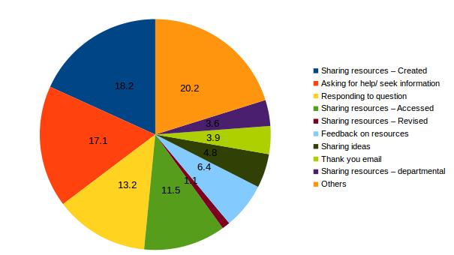

Source – Maths Science teachers google group (mailing list) : Mails for the first 2 weeks in August 2014

Note:
Sometimes, an email could be of more than one kind. It could answer a question as well as share a resource, in which case it has been counted under both. This is the reason why the total is more than 323, the number of emails studied.
Sharing created resources is the single largest category of emails (65). Mails asking for clarification (seeking help/ information) is the next largest category of emails (61). Teachers respond to questions asked either in an email or by sharing other resources (created/ accessed). Teachers also share feedback and revise resources shared. The number of mails with resources created by teachers is more than the number with accessed resources being shared. This suggests teachers are open to creating resources on their own.

Format of resources shared
In the traditional model of resource creation, text was the predominant format of resource creation. Digital methods, even if they were used, tended to largely be representations of text. This was the outcome perhaps of the first generation of ICT implementation programs which tended to focus on a limited set of applications.
The PLC members, on the other hand, having been trained in multiple digital tools have been able to more freely imagine resources in multiple formats. Among the resources shared, text is the most common format of resources. Geogebra and image files are the second largest category of resources shared. Strengthened by their knowledge of multiple tools, teachers’ conceptions of resources have expanded to documenting classroom processes – field vists, lab work, specimens collected, places visited, etc. As an example, one of the teachers in the PLC whose resources have been uploaded on the OER repository, self recorded the making of a drawing of the human ear along with a voice narration thus creating a resource, mixing in multiple formats (image, video of the image being drawn and the audio of the narration).

An understanding of the nature of OER
While studying the emails, we attempted to determine if teachers were sharing resources consciously as OER (or as non OER). An explicit OER is where a resource is shared under a liberal license such as the Creative Commons license. We found that the largest number of emails were of resources that were shared without any explicit license. However, based on the analyses of emails, it is clear that teachers have intended to share their resources for others to download and use (for re-use) and hence we have categorised such sharing as implicit OER. In many cases, teachers have also explicitly asked for the resource they have shared to be revised and shared back.
Teachers are implicit in their assumption of sharing their resources as Open Educational Resources as can be seen from the fact that often times an email conversation is a resource (the question, answer and discussion). Very rarely resources are shared explicitly as OERs. For the purposes of this analysis, we have included resources/ links from known OER sources as explicit OERs.
Table 5 - Awareness of OERs
Explicit non-OERs | 19
Implicit non-OERs | 9
Implicit OERs | 198
Explicit OERs | 16
Total | 242
Source – Maths Science teachers google group (mailing list) : Mails for the first 2 weeks in August 2014

In a textbook culture dominated system, where the state supplies textbooks and materials free of cost, there seems to be an implicit idea that educational resources must be open. Further, there seems to be a belief among teachers, shared during focused group discussions that resources shared online are free to use; an understanding of the copyright principles of OER was not common. This misconception seems to be guiding teachers’ sharing of resources in the PLC, though the intent seems to be making the resource an OER – allowing reuse, seeking feedback to revise and so on. The following email snapshots show examples of such sharing.
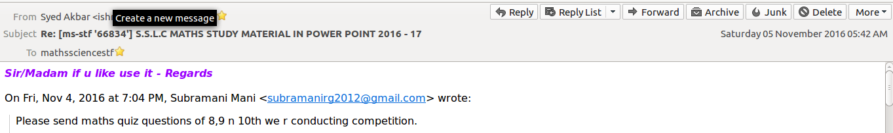
This is an email sent by a PLC member asking for resources for a particular purpose. A core group member has responded with a resource; implicit in the sharing is the principle of “reuse-revise-redistribute” of OER.
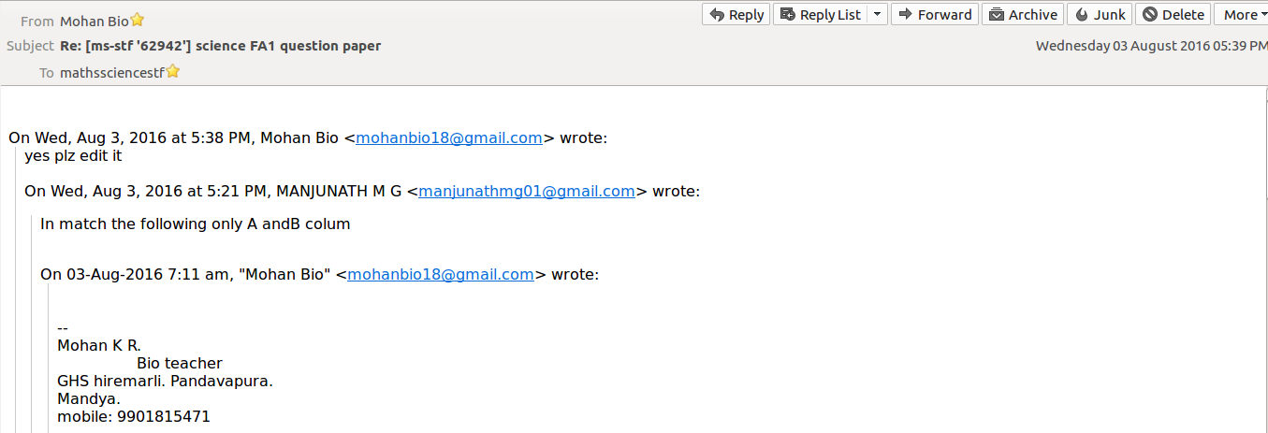
In this example, a teacher has pointed out the need for a correction in a resource shared. The core group member has explicitly responded asking the user to “edit” it.

Big data analyses of the PLC mails using Watson
Analyses of the mailing-list was done using the Watson analytics software and SPSS data modeller. The entire body of emails (which is ‘big data’ given the large number of emails) for the Mathematics and Science PLC was ‘machine-read’ and analysed using the Watson analytics software, combined with the SPSS data modeller, in collaboration with a team from IBM Watson analytics team.
Following are the important observations and analyses from this mail analyses using Watson:
- Geogebra is the most discussed tool amongst the Maths-Science teachers. Geogebra is a popular tool for creating mathematics lessons and suggests that conversations are led by resource creation needs and possibilities.
- The type of documents more popularly shared among the teachers are JPG & PNGs, followed by PDF documents. We saw earlier in our sample analysis that text and image are popular formats, though they are sharing resources in other formats as well. Teachers’ familiarity with tools of resource creation seems to determine the format of resources shared.
- Most of the responses by other PLC members to resources express gratitude for the resource shared. A relatively smaller number give detailed feedback. The PLC acknowledges and receives resources, however, the critical review and feedback are more advanced pedagogical processes and will take time to emerge. This process of review and feedback, is in itself a method of teacher development. Here again, the core group teachers have been able to play a larger role in modelling how to give feedback with specific suggestions as seen in the mail below.
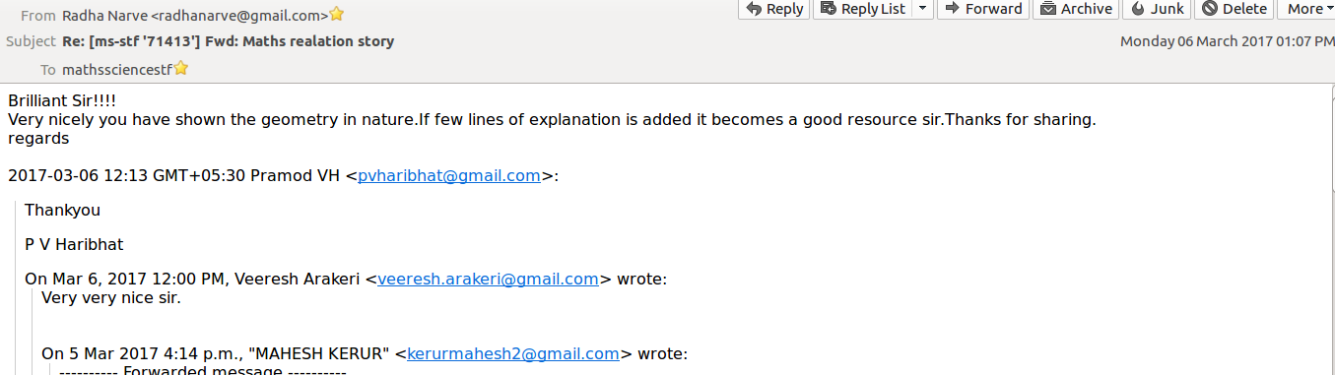
A teacher has shared an article he had written in a departmental magazine, which was met with simple responses of “very nice” and “thank you”. The core group teacher who has responded on top has acknowledged the work, pointed out what was done well and suggested ideas for improvement.
- Increasing share of mails are being read on mobile devices, suggesting changes in the way teachers are accessing emails and hence, resources. This will have implications on the kinds of resources that will be created by teachers.
- Unique senders in maths science mailing list in first five years is 4738, over the period 2011-16 were studied. The following table gives this data for core group and other PLC members.
Table 6 – Unique mails in the PLC
 | 2011 | 2012 | 2013 | 2014 | 2015 | 2016
Core group unique mail senders | 4 | 27 | 30 | 34 | 35 | 22
Other PLC members unique mail senders | 90 | 907 | 808 | 1171 | 2543 | 1795
Source – Maths Science teachers google group (mailing list) : Mails from June2011 – May 2016

This is 46.5% of the total membership of the group, of 10,180 teachers as of May 2016. This suggests a very wide range/extent of teacher participation in the mailing lists. 41 of the 44 core group teachers and 4695 of the non-core group teachers made posts to the forum till May 2016. In any mailing group there are a large percentage of ‘lurkers’ who read but do not post. Nearly half of the PLC members have posted to the lists.

Dialectic between the OER core group and the PLC

Membership of the core group
While traditionally there was a “textbook creation team”, a virtual forum in which teachers from across the state participated gave more visibility to resource creation efforts by different teachers. Several of the core group members were active participants in the PLC sharing ideas, resources and responding to questions from the PLC. Many of the core group teachers were also leading district resource persons and were frequently called upon to lead and support the district level teacher training for the STF program. The core group have been acknowledged as leaders in the PLC; this is borne out by the email conversations in which the core group members have participated.
Table 7 - Mails shared by the core group in the PLC, per member
 | Core group | PLC | Total Result
Number of mails | 4898 | 52887 | 57785
Number of teachers | 41 | 4696 | 4737
Mails per teacher | 119.46 | 11.26 | 12.20
Source – Maths Science teachers google group (mailing list) : Mails from June2011 – May 2016

Core group members have shared much higher number of mails, providing leadership to the PLC. Some of the ways in which the core group members have participated in the PLC include:
- Sharing resources
- Giving feedback on a resource shared by a PLC member
- Clarifying questions raised – on content, pedagogy or technology
- Acknowledging a resource contribution made by another colleague
Sometimes, these were conversations between core group members who were able to share critical reflections on a resource shared. Having benefited from processes of OER creation and review, it appears that these teachers were keen to share their learnings with the PLC.
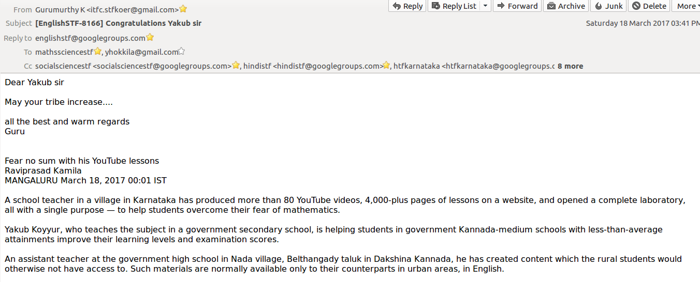

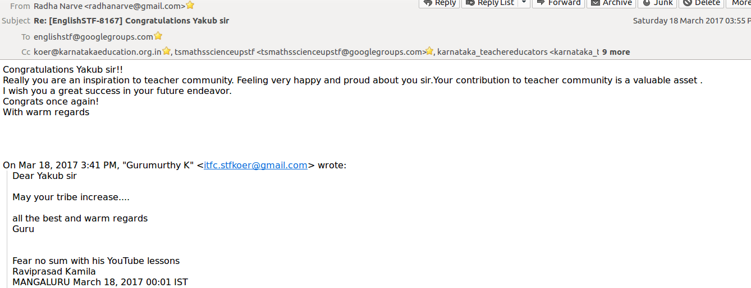

The work of a prolific contributor to the PLC has been celebrated in the media and this article was shared in the forum by one of the authors. While many teachers acknowledged his work, a core group member has gone beyond the customary “good work” to speak about the idea of a community of learning for teachers and appreciated his contribution for the teachers’ community

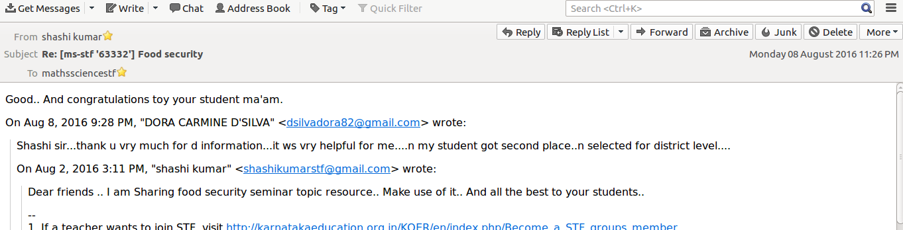
This is an example of a conversation where the core group member has shared a resource for other teachers to use and is acknowledging the achievement of the other teacher (student).

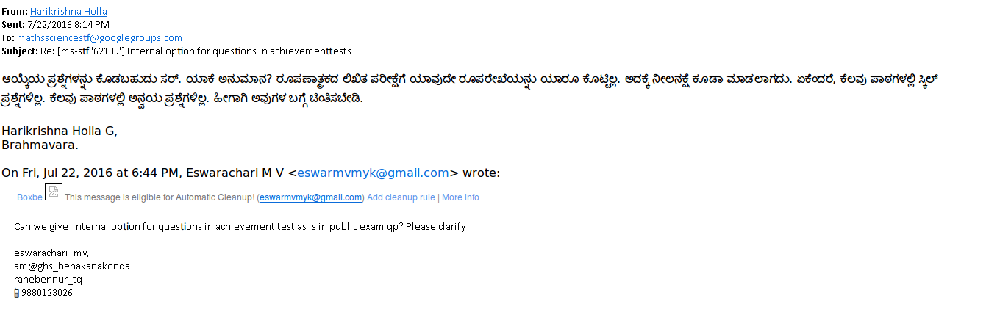
In yet another example, another PLC member has asked a clarification on an academic process, which is being responded to by the core group member.

PLC both a source and context for OER creation
The core group was formed as a small sub-group of the PLC with the objective of creating a cohort that will be trained in the creation and publishing of digital content in the form of OER. However, they seemed to imagine the resource creation as a more distributed activity situated in the PLC. They seemed to have the opinion that the resource creation is a larger collective activity and the core group is seen more to have a custodial/ editorial function. This is exemplified in their articulation of the role and the expectations of the PLC in the focus group discussions.

Influence of PLC interactions on OER design and creation
One of the distinctive features of the OER creation process was the participatory nature of the OER creation. The teachers ideated on the form of the resource repository, the structure, the kinds of resources to add as well as the user interface to the platform. The content organization on KOER has largely flown from these discussions during which the core group articulated teacher needs in terms of content and ways of representation. The table below shows an example of how a resource is getting developed through conversations within the PLC.
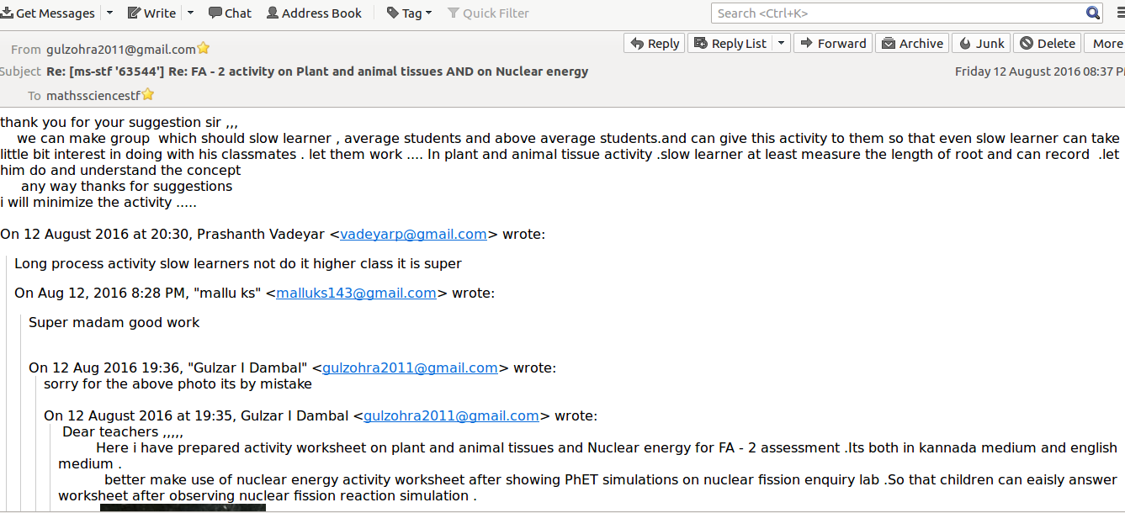
A resource with an activity for using a simulation has been shared by a teacher,yet another active member of the PLC. The resource has created a context for teachers to have a conversation on how to address different kinds of learners and resulted in the teacher revising her creation.
One key idea of OER creation emerged from the core group’s articulation of resource requirements was the development of video resources for conducting science experiments. This requirement articulation emerged from the PLC – the state-level forum as well as the district level forums – that the core group is a part of.
Another reason for this perspective on OER creation perhaps came from the difficulties – technological, pedagogical and logistical – faced by this core group in terms of creating resources. While the processes of OER creation enabled their development, many teachers expressed dissatisfaction at the rate of OER creation. They felt that the community is an important source of resources and that “teachers feel the need and they respond to the need”. They perceived the large size of the government school as a strength and felt that the resource creation group should be expanded to include more members from the PLC. They also suggested the formation of district level resource groups.
The core group of teachers were also able to articulate key technological requirements of the resource repository. These included methods of easily embedding resources from other cloud based repositories that teachers access (as an example, embedding a slideshare presentation or a video), visually intuitive editing features, categorization of resources and advanced search features that allows for search on multiple dimensions.

PLC as a forum for disseminating OER
As we saw earlier, “textbook creation” was seen as a career progression by teachers. With the digital enabling multiple methods of resource creation, more teachers came to be acknowledged as differenSt resource creators. There was also a strong sense of community and identity the core group of teachers expressed with the PLC. In addition to the personal recognition of themselves, they clearly articulated the need to “popularize” the OER platform among teachers, through the PLC. They also recommended that all the teachers should be part of the PLC. Disseminating KOER through newsletters, writings in departmental communication pieces, talking about the OER platform in other training programs. They argued that it was important to receive the feedback from the teachers in the PLC who they felt were their peers. The core group suggested discussion forums to be set up where comments from the PLC could be obtained for revising the resources.
Another interesting aspect we observed is that teachers who are part of the core group, in addition to creating and publishing on the resource repository, continued to share resources on the PLC, clearly suggesting that they see the PLC as an important way to disseminate the OER.
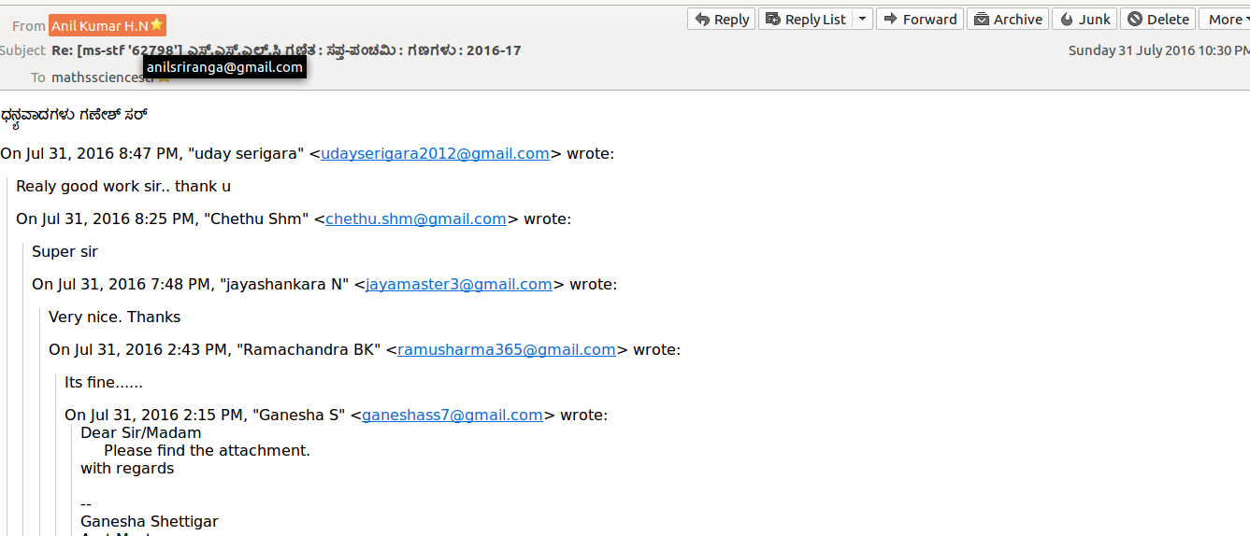
This core group teacher started a project to systematically prepare students for the exams and shared resources in a series in the forum, which was received well in the forum and even created a sense of anticipation in the teachers. In this thread, another core group teacher is seen acknowledging the mail.
It seemed that from the core group’s perspective, the OER creation process derived its validity being embedded in the PLC, and the larger teacher community.

Challenges
- While the PLC and the OER creation process have a dialectic that can provide a model of sustainable, contextually relevant resource creation, there need to be departmental processes and structures that will allow continuous cycle of creation-feedback-review.
- OER publishing requires technological capabilities, pedagogical understanding and content mastery, alongwith a good understanding of the principles of organizing content in coherent frameworks. It is difficult for teachers to develop all these skills, especially when they are loaded with the demands of a high school syllabus. Therefore, the core group publishing of resources – either created by themselves or accessed from the PLC – was not happening to the extent the authors had imagined.
- Technology is impacting society continuously. Social media, “easy to consume” cloud based content solutions seem attractive in the face of long term efforts like Teacher Professional Development. Whatsapp based sharing seemed to be preferred by many teachers over an organized repository even though the long term benefits were accepted and understood. A participatory approach to OER creation in a teacher community is an idea that takes time to mature and needs the support of policy makers and educational administration.

Conclusion
A mailing list based PLC that can support continuous teacher professional development, is in line with the recommendations for principles of in-service teacher education. Teacher capacity building in digital methods is critical for this possibility to be actualized. The creation of a free and open technology environment is essential for such collaborative models to develop and sustain.
It appears that neither the PLC nor the core group could have been sufficient unto itself. We can see that the PLC interactions, in which the core group were active participants, gave them the ideas for the form, structure and content of the repository. On the other hand, the core group with their incremental experiences in resource creation were able to provide academic leadership to the PLC. It is important to note that this dialectic has emerged almost entirely autonomously without any departmental guideline or directive, suggesting that community spaces can indeed support OER creation and teacher professional development.
An OER creation process, embedded in a larger PLC which has created the required ecosystem for techno-pedagogic intergration seems to hold the promise of sustained resource creation. A distributed resource creation model, where teachers are contributing “all for all” (as quoted by a core group teacher) can potentially leverage the large size of a government school system, to create diverse, contextual and a large variety resources. However, reviewing, giving feedback and sustaining the publishing all need to be prioritized by the Education department and needs to be balanced within the overall load of the teacher. Resource provisioning in terms of training, infrastructure and teachers’ time to task management are critical for this model to sustain.

See http://karnatakaeducation.org.in/KOER/en/index.php/Subject_Teacher_Forum
See http://karnatakaeducation.org.in/KOER/en/index.php/Main_Page
This is an annual compilation of information from all schools, by the MHRD (Ministry of Human Resources Development), Government of India
See UNESCO. 2014 Education for All Global Monitoring Report (GMR), accessible from http://en.unesco.org/gemreport/allreports
TPACK Development in Teacher Education: A Longitudinal Study of Preservice Teachers in a Secondary M.A.Ed. Program, Mark Hofer
Constructionism: Theory of Learning or Theory of Design, Chronis Kynigos, Educational Technology Lab, Department of Education, School of Philosophy, University of Athens
The Sarva Shikshana Abhiyaan 16 (Sarva Shiksha Abhiyaan, 2008) programme of the central government, adopted by all provincial governments requires a lower primary education (grades 1 to 5), and upper primary school (grades 6 to 8) within 3 km within 1km of every habitation
National Curriculum Framework for Teacher Education, 2009
Mathematics and Science teachers as at the end of September 2017. The number of teachers in all forums (Mathematics, Science, Social Science, Kannada, English, Hindi and Head Teachers) is 28,991 as at the end of September 2017
Wawasan Open University (2016). Open Educational Resources, Vignettes of selected Asian experiences.
We use the term ‘adoption’ in a broad manner to include access, creation, revision, sharing and use.
The mailing-list was a google group, this is accessible at https://groups.google.com/forum/#!forum/mathssciencestf
Tool used for creating animations and lesson plans for mathematics, see http://www.geogebra.org/cms/en/
Prof. Rajaram Sharma, Open Educational Resources: Building Communities and Building Knowledge, Vignettes of selected Asian experiences
KOER page link
https://en.wikipedia.org/wiki/Watson_(computer)
The technology training proceeded in phases – determined by the availability of ICT infrastructure. This meant that all the teachers were covered over a period of time; by the end of the period of study in 2016, all mathematics and science teachers had become part of the PLC.

